**ISOM3002-001 Analysis & Design of Information Systems**

Part C - System Design Report

LUO XIN BB906798

LUO JUNLIN BB906647

CAI SHAOPENG BC005388

CHNAG IMLAN BB803164

HUANG SHURUI BC005001

SONG JIANBO BC005303

Date of Submission: May 6th, 2022

**PART Ⅰ -- INTRODUCTION**

**1.1** **General Introduction of Target Company** **(MEGA)**

This is a video rental store. It rents tapes and VCRs. If a new customer wants to rent a tape in the store, they need to register as a member first. After they register successfully, they will get their own membership number and membership card.

Once they have a membership card, customers can browse through the storyboards on empty boxes of tapes and VCRs in stores. If the guest returns late, he will be charged an additional late penalty. And if the tape is borrowed, the empty box will be removed from the shelf until the customer returns it. This company will not charge the last rental fee until the next rental. When the customer wants to return the goods, they need to put the tape into the return bin, and the staff will input the return date of these tapes into the system. Renting a VCR is like renting tape, but since a VCR is more expensive, customers need to sign a contract.

MEGA VIDEO generates two reports each week. The first report is used to urge customers to return goods and pay charges. Long-term expectations of non-return of goods and non-payment of fines will be disciplined when their account is forwarded to a collection agency. They are dropped as members. And this report is filed with the credit bureau.

The second report recorded costs incurred due to late returns and it is used only for records.

**1.2 Motivations of Designing the Proposed System**

Due to the small size, the company decided to manually process all the business transactions as well as manage all the customer information when it was established. This manual customer information management system was suitable for the company at the beginning stage of its operation, however, with the development of the company, this manual system is no longer efficient enough to support the daily operation and management of the customer data. In the following space, we will specify some problems with the current system, which reflect the necessity of designing a new system to support the company’s daily operation.

***(1) Single payment method***

Currently, the only payment method accepted by the system is credit cards, which is very inconvenient for users who forget to bring their credit card. And we think that in the payment process, we should provide more options, such as cash, check, and electronic payment (WeChat payment, Alipay).

***(2) Single way of identification***

When a member enters the store to borrow a product, the current system only accepts the identification method of the membership card, and it will be very troublesome if a member forgets to bring his own membership card. And we think besides membership cards, customers can also use membership card numbers and mobile phone numbers for identity authentication.

***(3) Inefficient way to recall tapes and VCRs***

Currently, the system generates a weekly list of unreturned users and sends them emails manually. This approach is neither timely nor efficient enough.

A computerized system that automatically sends emails to users on the list urging them to return the product would reduce employee workload and increase efficiency. In this way, even if we generate a list every day, it will not be too complicated.

***(4) Improper overdue handling***

In the current system, if the items have not been returned after two weeks from the due date, the account is forwarded to a collection agency, the customer is dropped as a member, and a report is filled in with the credit bureau. This approach makes customers less willing to return the product.

For customers who are more than two weeks overdue, we can send a warning email telling them that the deadline has been exceeded and we will keep their membership for 6 months but suspend all their membership benefits until he returns the product. If the customer returns the product and pays the relevant fees during this six-month period, their membership will be reactivated, and he will be able to enjoy membership benefits again. But if he fails to return and pay within six months, his default information will be turned over to the credit bureau and his membership will be canceled.

Based on the alert list above, we will generate a list of lost items, which will generate another report. This report is not only used for internal records but also serves as a replenishment list to replenish these lost products.

***(5) Inefficient management of products information***

The product information needs to be entered by the cashier, which creates more repetitive work and there is a risk of error. If the cashier wants to know the status of all products, he/she needs to check each counter in person, which is more troublesome. Customers need to sign a contract when borrowing VCRs. The storage, search, and management of the contract will increase the workload of the staff. The use of paper contracts also increases operating costs and is not environmentally friendly.

A unique number was assigned to each tape and VCR, and a database (product information system) was created to correspond the specific information of the tape and the VCR with their number. By scanning the numbers on the tape, you can browse the specific information (name, content category), total quantity and remaining quantity of the tape.

At the same time, when the customer checks out, the cashier does not have to manually enter this series of information. Just scan the barcode of the item, the product information (including name, quantity, and price) will be automatically presented, and the bill will be automatically generated.

As for contracts when borrowing VCRs, we generate an electronic contract database. Signing electronic contracts saves paper and is environmentally friendly. Moreover, it is more convenient to form an electronic contract database when saving, viewing, and calling contracts.

**PART II – OVERALL ACITECTURE OF PROPOSED SYSTEM**

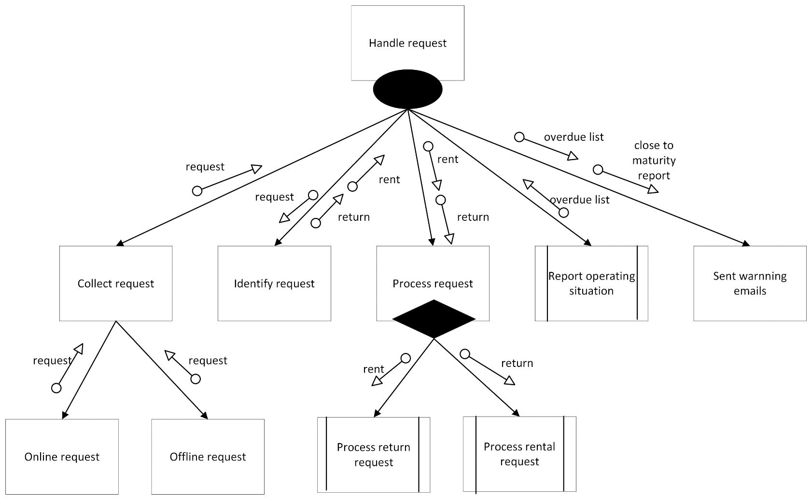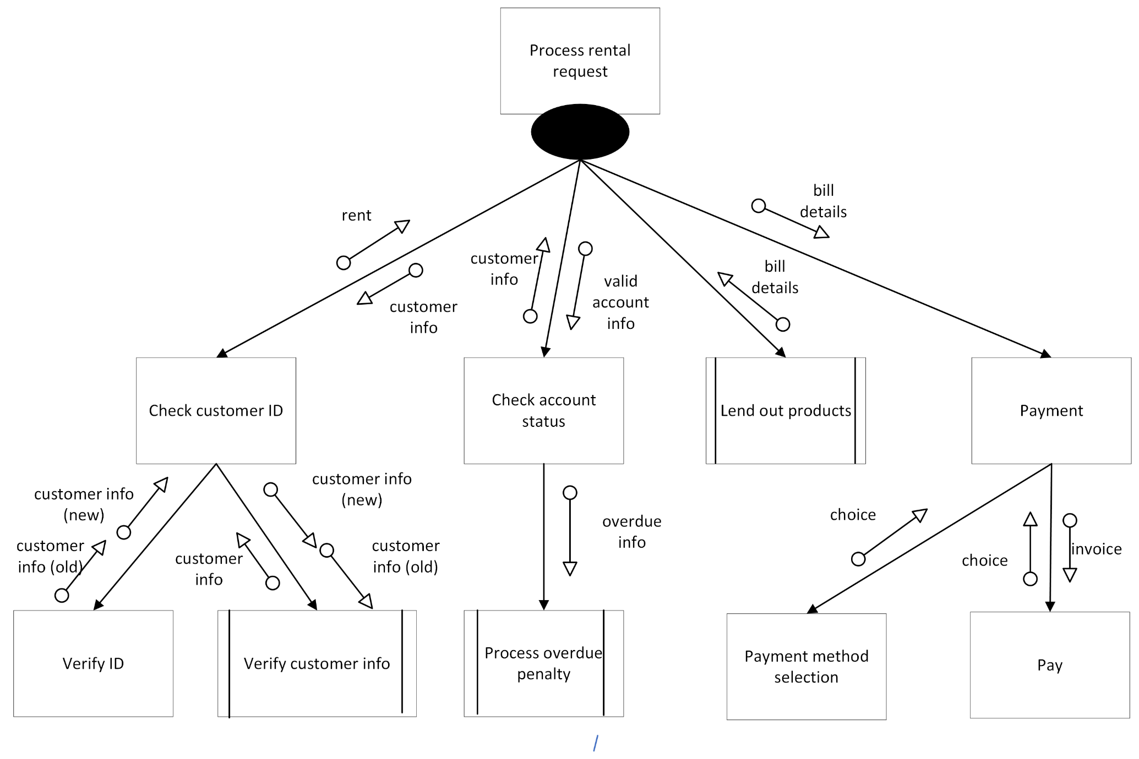**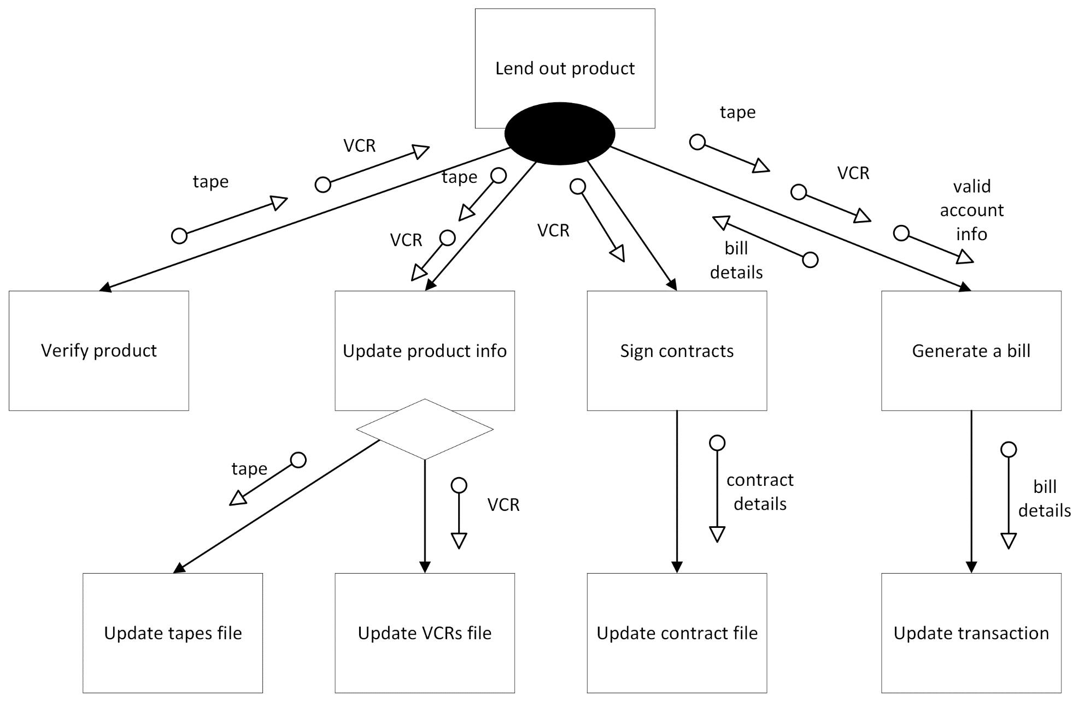



**PART III – INPUT / OUPUT REQUIREMENTS**

**3.1 Input form & screens**

3.1.1 Membership application form

U,{121b89b3-b6a1-4638-b191-3db4303ade03}{35},10,6.666666666666667

3.1.2 Membership application form (for online users)

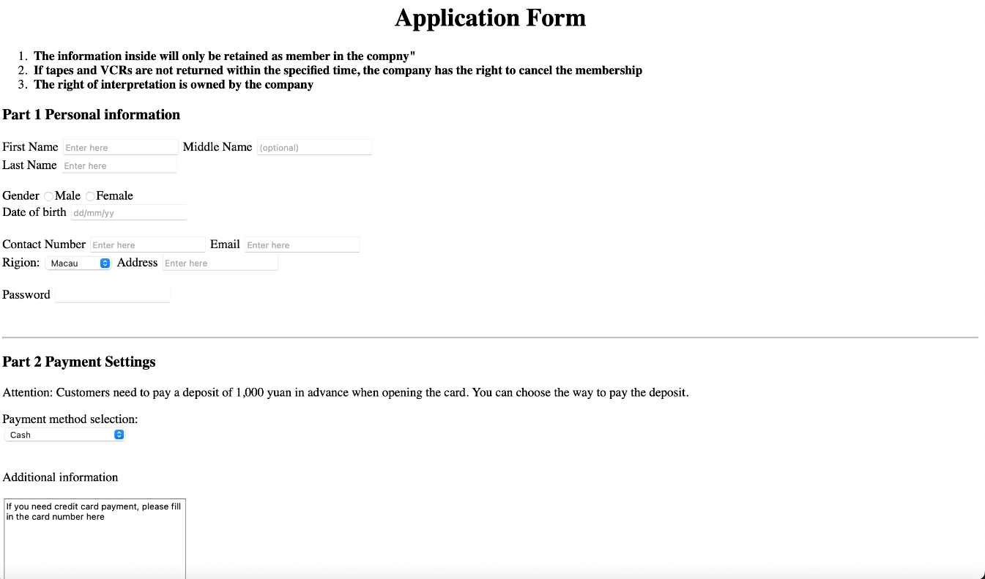

3.1.3 Screen for checking the availability of videos by product code or product name

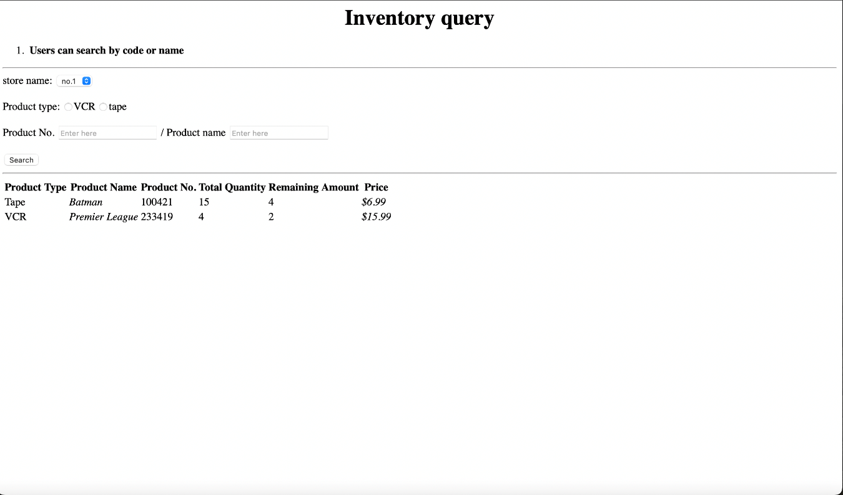

3.1.4 Screen for video renewal

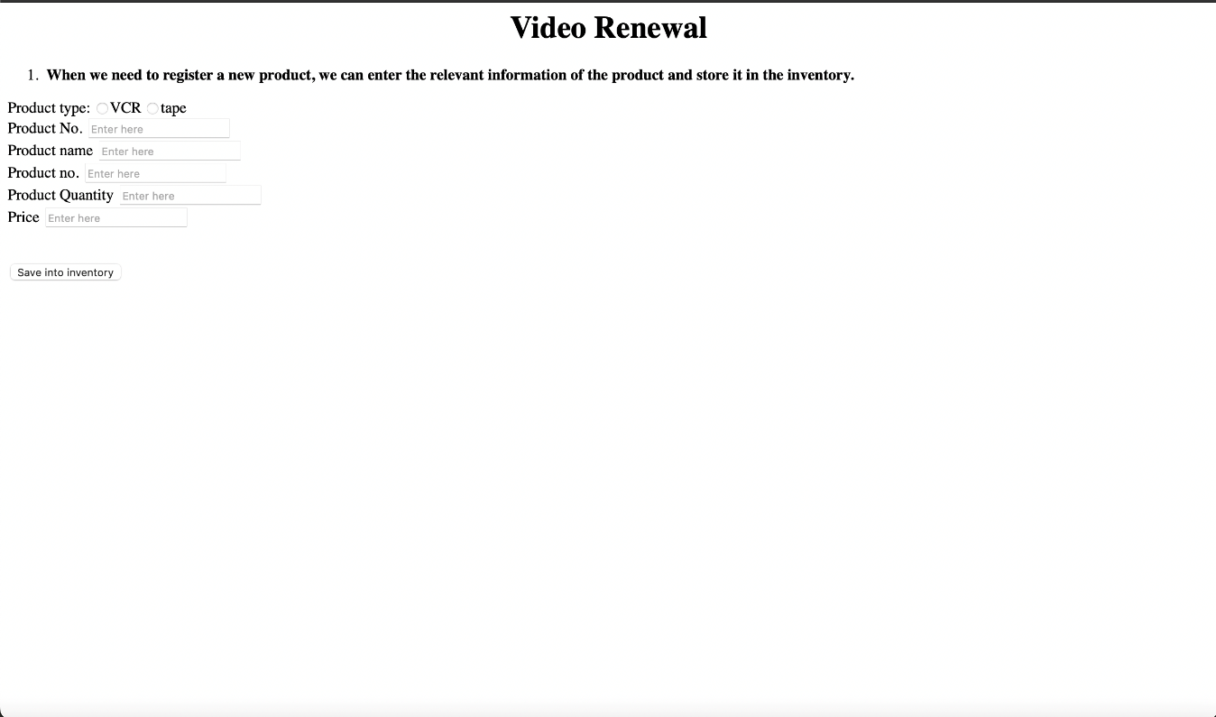

3.1.5 Screen for check-in videos

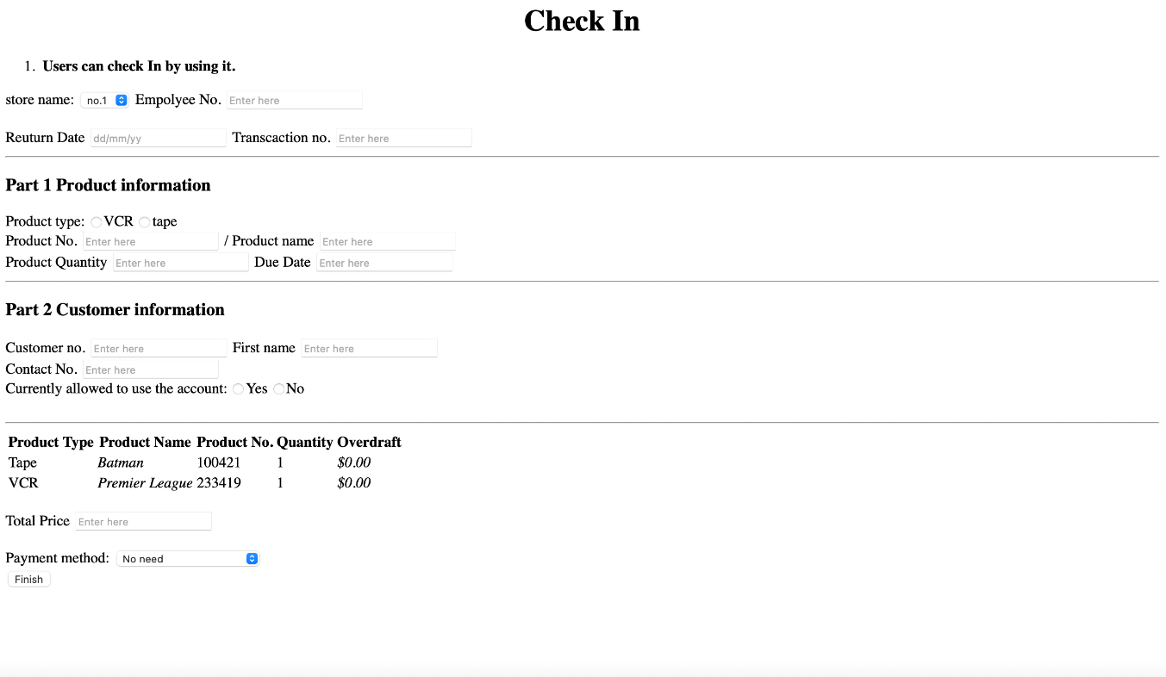

3.1.6 Screen for check-out videos

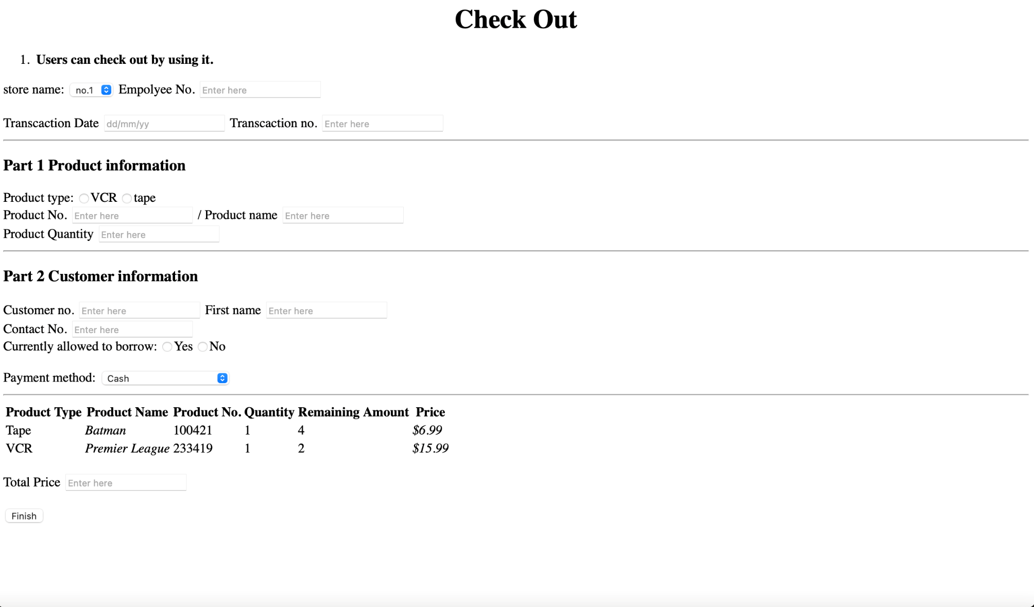

**3.2Output reports and forms**

3.2.1 Videos overdue report

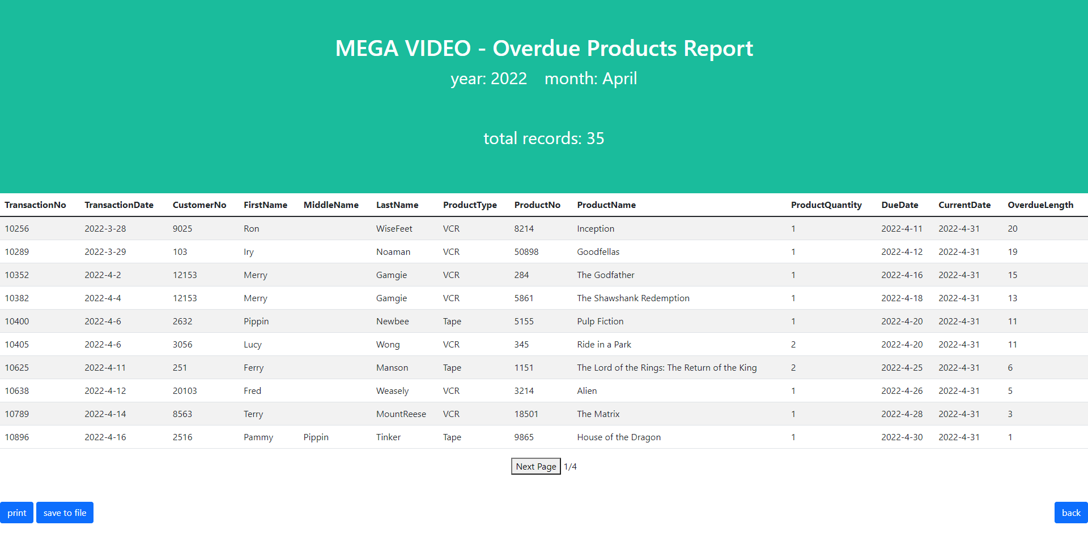

3.2.2 Urging return list report

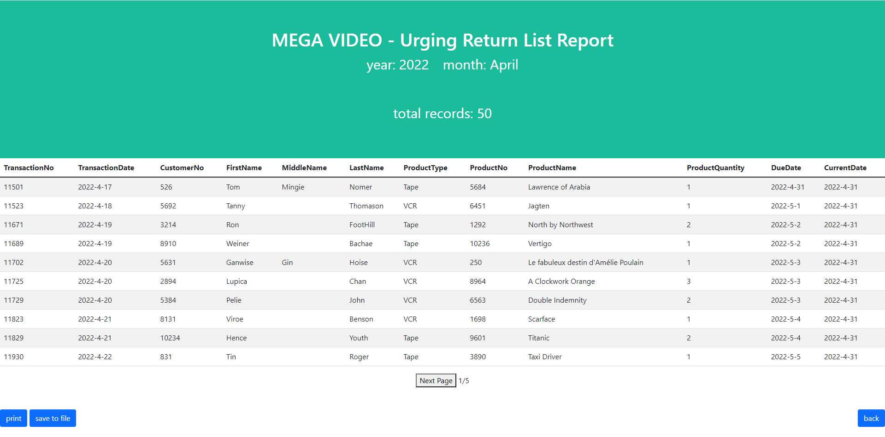

3.2.3 Most popular video report

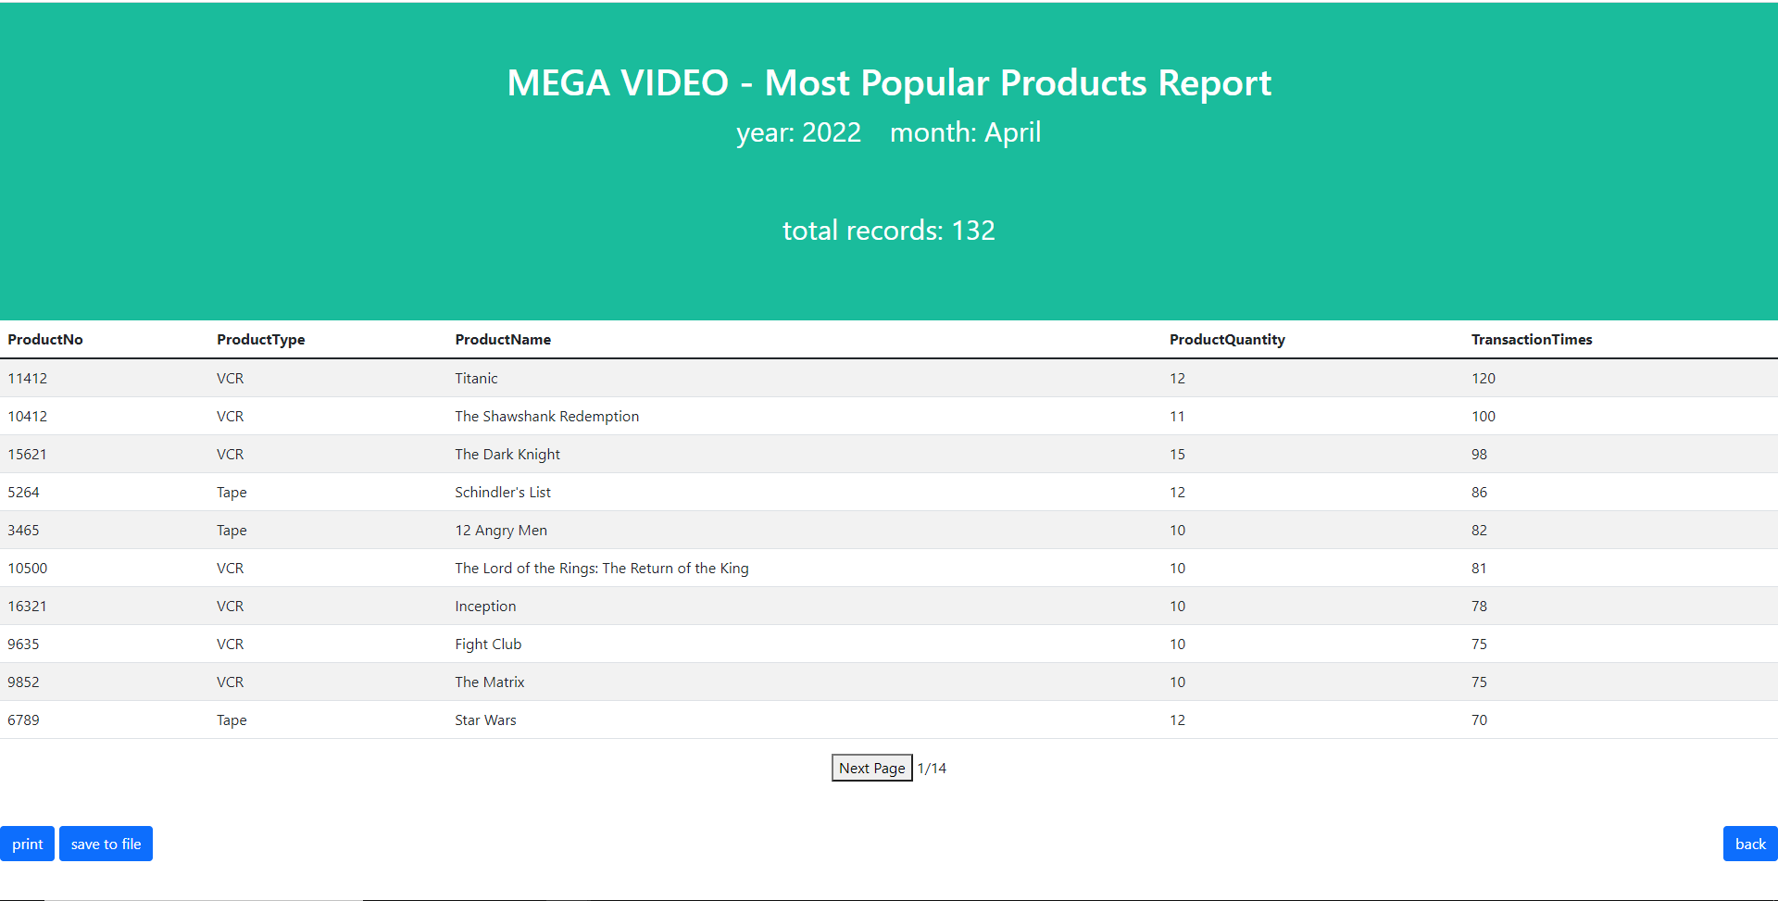

3.2.3 Invoice

Invoice

Customer No.:____10086___

Customer Name:___XXXXX_____

Email Address:___abcd@gmail.com_

Products details

|  |  |  |  |
| --- | --- | --- | --- |
| No. | Video Code | Video Name | Charges |
| 1 | T12344 | XXXXX | MOP 80 |
| 2 | V22442 | YYYYY | MOP 100 |
| 3 | T23456 | ZZZZZ | MOP 30 |
| 4 |  |  |  |
| 5 |  |  |  |
| Total Charges | | | MOP 210 |
| (Sign here) | | | Date:  Mm/dd/yyyy |

**MEGA VIDEO’S**

**PART IV – FILE & DATABASE DESIGN**

|  |  |  |  |
| --- | --- | --- | --- |
| CUSTOMTER FILE | | | |
| Attributes | **Data Type** | **Length** | **required?** |
| CustomerNo | AutoNumber | 20 | Yes |
| FirstName | Short Text | 10 | Yes |
| MiddleName | Short Text | 10 | No |
| LastName | Short Text | 10 | Yes |
| Gender | Short Text | 1 | Yes |
| DateOfBirth | Date | 10 | Yes |
| Floor | Short Text | 2 | Yes |
| Building | Short Text | 50 | Yes |
| Street | Short Text | 50 | Yes |
| City | Short Text | 50 | Yes |
| PostalCode | Number | 10 | No |
| ContactNo | Number | 15 | Yes |
| EmailAddress | Short Text | 20 | Yes |
| CreditCardType | Short Text | 10 | Yes |
| CreditCardNo | Number | 20 | Yes |
| ApplicationDate | Date | 10 | Yes |
| ApplicationNo | AutoNumber | 19 | Yes |
| MenbershipStatus | Short Text | 10 | Yes |

|  |  |  |  |
| --- | --- | --- | --- |
| APPLICATION FILE | | | |
| Attributes | **Data Type** | **Length** | **required?** |
| ApplicationNo | AutoNumber | 19 | Yes |
| FirstName | Short Text | 10 | Yes |
| MiddleName | Short Text | 10 | No |
| LastName | Short Text | 10 | Yes |
| Gender | Short Text | 1 | Yes |
| DateOfBirth | Date | 10 | Yes |
| Floor | Short Text | 2 | Yes |
| Building | Short Text | 50 | Yes |
| Street | Short Text | 50 | Yes |
| City | Short Text | 50 | Yes |
| PostalCode | Number | 10 | No |
| ContactNo | Number | 15 | Yes |
| EmailAddress | Short Text | 20 | Yes |
| CreditCardType | Short Text | 10 | Yes |
| CreditCardNo | Number | 20 | Yes |
| ApplicationDate | Date | 10 | Yes |

|  |  |  |  |
| --- | --- | --- | --- |
| TAPE PRODUCT FILE | | | |
| Attributes | **Data Type** | **Length** | **required?** |
| TapeNo | Number | 10 | Yes |
| TapeName | Short Text | 50 | Yes |
| TotalQuantity | Number | 5 | Yes |
| RemainingAmount | Number | 5 | Yes |
| ProductType | Short Text | 5 | Yes |

|  |  |  |  |
| --- | --- | --- | --- |
| VCR PRODUCT FILE | | | |
| Attributes | **Data Type** | **Length** | **required?** |
| VCRNo | Number | 10 | Yes |
| VCRName | Short Text | 50 | Yes |
| TotalQuantity | Number | 5 | Yes |
| RemainingAmount | Number | 5 | Yes |
| ProductType | Short Text | 5 | Yes |

|  |  |  |  |
| --- | --- | --- | --- |
| TRANSACTION FILE | | | |
| Attributes | **Data Type** | **Length** | **required?** |
| TransactionNo | AutoNumber | 20 | Yes |
| TransactionDate | Date | 10 | Yes |
| CustomterNo | Number | 20 | Yes |
| FirstName | Short Text | 10 | Yes |
| MiddleName | Short Text | 10 | No |
| LastName | Short Text | 10 | Yes |
| ProductType | Short Text | 5 | Yes |
| ProductNo | Number | 10 | Yes |
| ProductName | Short Text | 50 | Yes |
| ProductQuantity | Number | 5 | Yes |
| PaymentAmount | Number | 5 | Yes |
| PaymentMethod | Short Text | 10 | Yes |
| DueDate | Date | 10 | Yes |
| ReturnDate | Date | 10 | No |
| ReturnStatus | Short Text | 10 | Yes |
| ContractNo | Number | 20 | No |
| EmpolyeeNo | Number | 10 | Yes |

|  |  |  |  |
| --- | --- | --- | --- |
| CONTRACT FILE | | | |
| Attributes | **Data Type** | **Length** | **required?** |
| ContractNo | AutoNumber | 20 | Yes |
| TransactionNo | Number | 20 | Yes |
| ContractDate | Date | 10 | Yes |
| DueDate | Date | 10 | Yes |
| CustomerNo | Number | 20 | Yes |
| FirstName | Short Text | 10 | Yes |
| MiddleName | Short Text | 10 | Yes |
| LastName | Short Text | 10 | Yes |
| VCRNo | Number | 10 | Yes |
| VCRName | Short Text | 50 | Yes |
| VCRQuantity | Number | 5 | Yes |
| PaymentAmount | Number | 5 | Yes |
| CreditCardType | Short Text | 10 | Yes |
| CreditCardNo | Number | 20 | Yes |
| CustomerSign | Short Text | 50 | Yes |
| EmpolyeeSign | Short Text | 50 | Yes |

|  |  |  |  |
| --- | --- | --- | --- |
| **EMPOLYEE ENTITY** | | | |
| **Attributes** | **Data Type** | **Length** | **required?** |
| EmpolyeeNo | Number | 10 | Yes |
| EmpolyeePassword | Short Text | 20 | Yes |
| FirstName | Short Text | 10 | Yes |
| MiddleName | Short Text | 10 | No |
| LastName | Short Text | 10 | Yes |
| DateOfBirth | Date | 10 | Yes |
| EmailAddress | Short Text | 20 | Yes |
| ContactNo | Number | 15 | Yes |
| Floor | Short Text | 2 | Yes |
| Building | Short Text | 50 | Yes |
| Street | Short Text | 50 | Yes |
| City | Short Text | 50 | Yes |
| PostalCode | Number | 10 | No |
| Position | Short Text | 20 | Yes |
| BankAccountNo | Number | 20 | Yes |
| WorkingHour | Number | 5 | Yes |
| Salary | Number | 10 | Yes |

|  |  |  |  |
| --- | --- | --- | --- |
| URGING RETURN FILE | | | |
| Attributes | **Data Type** | **Length** | **required?** |
| TransactionNo | AutoNumber | 20 | Yes |
| TransactionDate | Date | 10 | Yes |
| CustomterNo | Number | 20 | Yes |
| FirstName | Short Text | 10 | Yes |
| MiddleName | Short Text | 10 | No |
| LastName | Short Text | 10 | Yes |
| ProductType | Short Text | 5 | Yes |
| ProductNo | Number | 10 | Yes |
| ProductName | Short Text | 50 | Yes |
| ProductQuantity | Number | 5 | Yes |
| DueDate | Date | 10 | Yes |
| CurrentDate | Date | 10 | Yes |

|  |  |  |  |
| --- | --- | --- | --- |
| OVERDUE FILE | | | |
| Attributes | **Data Type** | **Length** | **required?** |
| TransactionNo | AutoNumber | 20 | Yes |
| TransactionDate | Date | 10 | Yes |
| CustomterNo | Number | 20 | Yes |
| FirstName | Short Text | 10 | Yes |
| MiddleName | Short Text | 10 | No |
| LastName | Short Text | 10 | Yes |
| ProductType | Short Text | 5 | Yes |
| ProductNo | Number | 10 | Yes |
| ProductName | Short Text | 50 | Yes |
| ProductQuantity | Number | 5 | Yes |
| DueDate | Date | 10 | Yes |
| CurrentDate | Date | 10 | Yes |
| OverdueLenth | Number | 5 | Yes |

|  |  |  |  |
| --- | --- | --- | --- |
| POPULAR PRODUCT FILE | | | |
| Attributes | **Data Type** | **Length** | **required?** |
| ProductType | Short Text | 5 | Yes |
| ProductNo | Number | 10 | Yes |
| ProductName | Short Text | 50 | Yes |
| ProductQuantity | Number | 5 | Yes |
| TransactionTimes | Number | 5 | Yes |

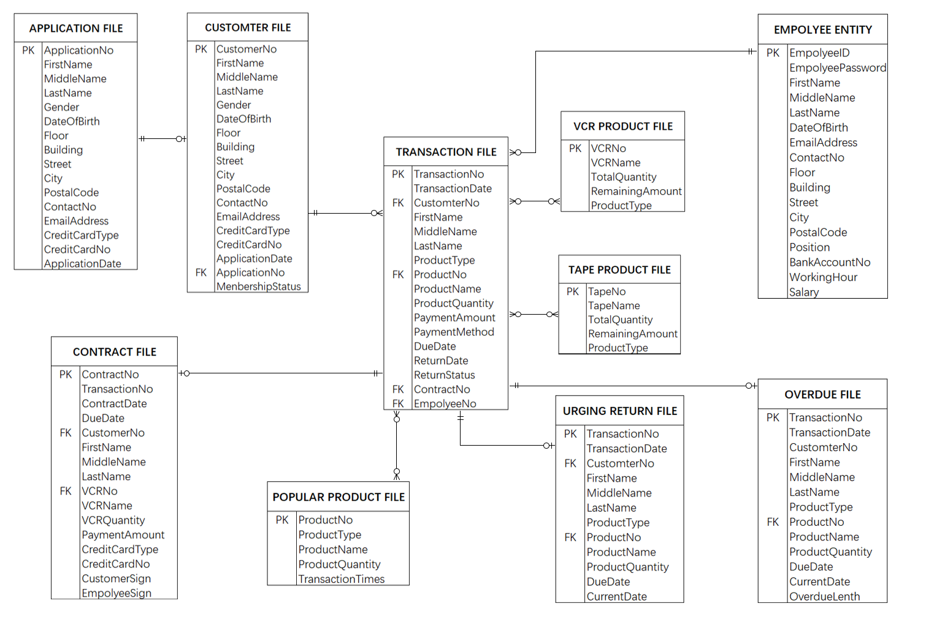

**PART V – SYSTEM CONTROLS & BACKUP**

**5.1 General control**

As our group concerns, only authorized users, namely, master, manager, accounting clerks, and counter employees, customers who have registered an account and customers who are about to register on the login page can get access to the MEGA VEDIO SYSTEM(MVS). When they use their user ID and user password to log in the system, the system will automatically compare these input data with those stored in the authentication files. After checking, if the input data is not valid, an error message either "Incorrect User ID!" or "Incorrect User password" will be displayed on the screen to inform the user. Through this way, the unauthorized login and unreasonable entry of data into the database can be effectively eliminated. Besides, the company should check monthly the login related records in the system log to ensure that there is no anomaly. Furthermore, necessary antimalware software should be installed and updated timely

**5.2 Input control**

**1. Validity check**

To prevent users from mistakenly input data which are not defined or existed in the master files, when users input data into the system, the system will automatically compare the related values in the corresponding expert files to ensure the validity of the input data. For example, at the end of the verification of customer's application form, if the staff has already finished the verifying process and concludes that all the information included in the application form is valid, then they will make a membership card for the customer and require the customer to pay a deposit. The deposit will be stored in the membership card, and the membership card number will be entered into the system and stored in the entry of the customer's account. After the system receives the entry of the membership card number and customer name, it will automatically access the customer expert file to verify that the entered membership card number and customer name exist. If these input data do exist, then the system will allow the worker to proceed with his/her input. If these input data do not exist in the corresponding expert file, the validation operation will terminate with the error message "Invalid customer number!" or "Invalid customer name!" will be displayed to the staff.

**2. Formal check**

To ensure that the data format entered by the user is always consistent with the predefined data format such as length and data type in the system expert file, when the user enters data into the system, the system will automatically compare the input data using the predefined data format. For example, when a user enters billing details, the billing date and due date must be in the format year-day-month. Otherwise, the system will display the error message "Incorrect input format" to the user.

**3. System log**

To ensure the security of the entire customer information management system, the system will automatically save every action of the user to the system log file provided by the system. In this way, if some users delete important records by mistake or intentionally, the company can find out who is responsible for the incident by consulting the system logs.

**4. Access control right**

Do not allow the user to modify certain inputs, such as the total amount due and the total amount paid, which have been checked and saved in the corresponding master file in the database to prevent fraud and false records.

**5.3 Processing control**

**1. Customer information control**

First, before the last version of the report is generated, the system automatically reconciles the contents of the receipt with the corresponding bill and accounting records to ensure consistency of all relevant records. Secondly, at the end of each month, the system automatically divides customer data into two parts - expired customer data (short-term unreturned merchandise customers and untrustworthy lists) and current customer data, and then transfers the expired customer data to another database. Specifically designed to store this obsolete data. This way, databases that are primarily responsible for supporting day-to-day operations are not overloaded with outdated data.

**2. Product information control**

Before the system automatically generates a product inventory report transaction report, the product information is checked, and the products are classified into products in stock, products on loan (within the return period), products not returned, and products to be purchased. The system generates reports at the end of the month, which reflect the status of the product and help managers make decisions.

**5.4 System backup**

System backup and recovery controls are considered standard provisions to provide reasonable assurance that the database can be recovered from any contingencies that occur on system hardware and software, such as loss or destruction of data processing facilities, hardware, software, or data. These continuation terms include retaining copies of data files and software, scheduling access to backup hardware for a brief period, and a tested recovery plan. For security reasons, it is recommended that Mega company back up all access files within the system to a disc or hard drive at the end of each month, and then save this external storage hardware to the company's safe deposit box.

**PART VI – CONCLUSIONS**

In conclusion, we recommend mega to replace the current manual operating system with this newly proposed electronic system for managing customer information for the following reasons. First, the proposed customer information management system can help companies update customer information more efficiently. For example, if a customer's contact number of changes, employees need to update this customer information, rather than tediously updating the customer's new contract number in a different manual data store (i.e., a paper notebook) as employees do. Now, the employee can simply update this customer information through the modification interface provided by the system, or the customer can log in the webpage to modify the information by himself, and the employee can check whether the information is valid. All other data files in the system that also contain this information will then be automatically updated. Secondly, by using the system, the overall operational efficiency of the company will be improved, especially the speed of processing customer requests. Because the system already consolidates all the needed information, employees do not have to find the information they need from several heavy notebooks before they can respond to a customer's request. And faster request processing can also bring several intangible benefits to companies, such as higher customer satisfaction and higher brand equity. Third, the system allows companies to store their important customer information in a more systematic and secure manner. A central database enables companies to centrally store data and share it with every employee. If there is an information problem, every employee of the company can visit the central database to solve it with all his heart, and the system will finally check.

This is the era of advanced information, and companies must keep pace with the times if they want to grow and grow. Technology changes destiny!